
SHED NO 27, SHUBHAM INDUSTRIAL ESTATE, NR. TORENT POWER SUB STATION, KATHWADA GIDC, AHMEDABAD – 382430
GST NO: - 24ARDPD2565K1ZX

info@torqpackagingsolution.com
www.torqpackagingsolution.com

DATE: - 09/12/23

To,
MR: JAI KISHAN SIR.

SUB: - AUTOMATIC 30 BPM BOTTELING PROJECT

Dear Sir,
Many thanks for your valuable inquiry of above subject. TORQ PACKAGING Solutions Is engage in making preliminary Bottle Packaging machines like bottle filling , capping , labeling, Automation, etc… in Ahmedabad, We are having dedicated team for manufacturing, customized machine development, Sales, servicing and back office.

Thanks & Regards
Ronak Dave
+91 80000 32128



TECHNICAL SPECIFICATION OF R. F. C. MACHINE
(Capacity: 30 BPM)
Rinsing Head : 6
Filling Head : 6
Capping Head : 3
Capacity : Min 30 BPM @ 1000 ml
Suitable Cap Shape : Plastic Cap
Bottle spec : 200 ml – 2 Liter
Air Conveyor : 12 Feet
Electricity : 5.0 KW
Dimensions (W x L x H) : 6 Feet X 7 Feet x 6 Feet
Weight : 800 Kg Approx.
Bottle Dimension : 95 mm (Diameter) Maximum
Height : 320 mm Maximum
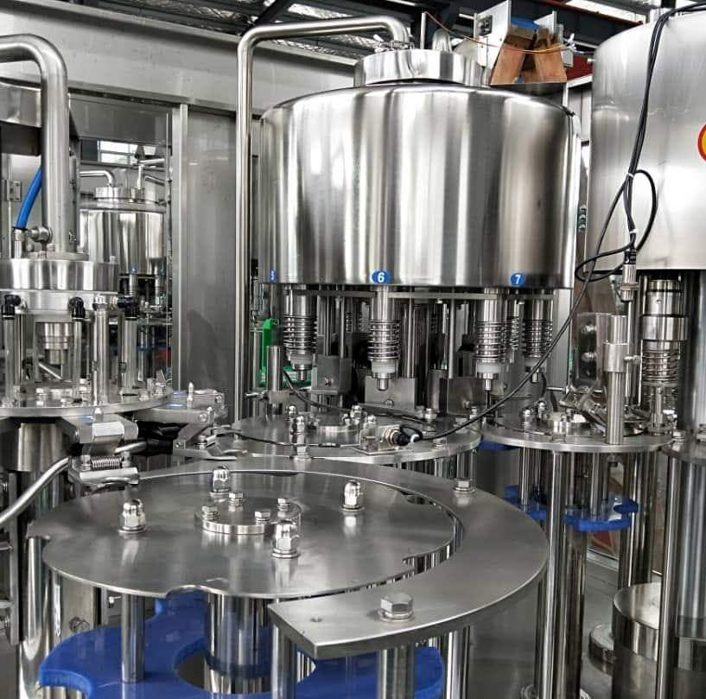

SR  NO. |  | TECHNICAL SPECIFICATION | MAKE
1 |  | Main Motor (1.5 HP)  Capper Motor (0.25 HP)  Cap Feeder (0.25 HP)  Conveyor Motor (2.0 HP) | ROTOMOTIVE
2 |  | Switch Gear | SCHNEIDER
3 |  | PLC  Relay Card 230 V AC | DELTA
4 |  | Material of Construction | SS 304
5. |  | Bearing | SKF
TECHNICAL DETAILS
1 | Main Drive Motor |  |  | 5 HP (3.0 KW) x 1440RPM x 415 VAC.
2 | Cap Hopper Gerard Motor |  |  | 0.25 HP (0.33 KW) x 1440 RPM x 415 VAC  Hopper Capacity 1000 Caps At a time  Material of contraction SS304  SS 304 Quality belt ¾” Size  Size (L x W x H ) - 3 feet 3 feet x 7.5 Feet Weight = 200 kg Approx.
3. | Electrical Control Panel |  |  | Inputs - Photo Sensor / Limit switch  Output - 230 VAC Valves
4. | Filling Valves |  |  | ½” BSP 230 VDC
5. | Proximity Switches |  |  | 24 VDC M18 Size (For No Bottle No Fill System)
6. | SS Shrink Tunnel |  |  | 4KW (440 VAC)
7. | Conveyor 16 feet (Air Conveyor) and 24  feet (Slat Conveyor) Geared Motor |  |  | 0.25 HP 32 RPM 440 VA Material  of construction SS304 Belt = ¾” Size material SS304 Adjustable legs for different size of bottle up to 300mm
MACHINE DIMENSONS
1. | Only Machine (L x W x H)  With Conveyor &All Accessories (L x W x H) |  |  | 6’ x 7’ x 6’ (FEET)  20’ x 11’ x 6’ (FEET)
WOODEN CARATE PACKING DIMENSIONS
2. | Main Machine (L x W x H)  Net Weight  Gross Weight |  |  | 98” x 98” x 102” (INCHES)  1800 KG2700 KG
3 | Accessories (L x W x H)  Net Weight  Gross Weight |  |  | 140” x 34” x 42” (INCHES)  800 KG1000 KG

SPECIAL FEATURE OF MACHINE
- Bottle Catching & All Star Wheels below the Neck Only.
- Instruction & Indication Systems.
- All Machine Part With Cnc Made.
- Programmable Logic Control With Hmi.
- Filling Water Tank Low & High Level Inter Lock.
- In-feed Air Blower Conveyor Ss 304.
- All Material Ss 304
- Cap Hooper Elevator Type & Having Capacity Of Min. 1000 Caps At A Time
- Out-feed Conveyor Ss 304.
Automatic Sticker Labeling Machine for flat bottle
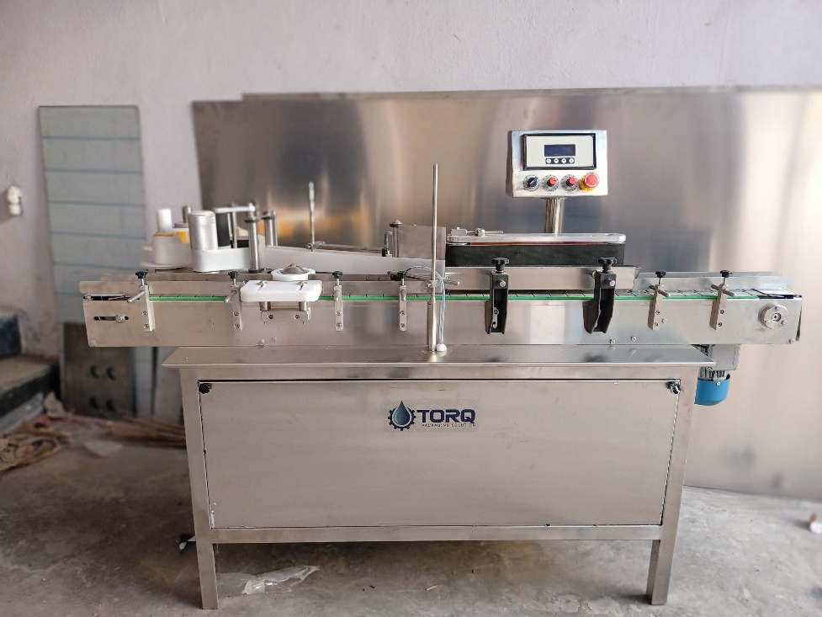
Description
The Automatic Vertical Sticker Labeling Machine is one of the most users friendly. The machine is used for full/partial labeling on different size of flat or rectangular containers. The automatic model is equipped with roller spacing device resulting in a simple operation with “No change parts required”.
Operation
The filled and sealed bottle is conveyed from the Conveyor and on the same conveyor one bottle separator attachment is provide to separate the bottle from continuous movement. A sensor provided to sense the product after sensing the sensor give command to operate steeper or servo motor to release label when one label is stick the gap sensor give command to stop the servo or stepper during releasing of label provision of brush to press the label & remove the air between label & bottle after completion of the cycle one operation of labeling is finish & conveyor bring the bottle for next operation..
Technical Specifications
Output/Hour* |  |  | 4000 to 6000
Direction of Movement |  |  | Left to Right
Controlling |  |  | Microprocessor base control
Power Consumption | Conveyor motor |  | 0.5 HP / 415 V / 50 HZ
 | Pressing device motor |  | 0.25 HP / 415 V / 50 HZ
 | Stepper motor |  | 60 kg / cm2
Height of Conveyor |  |  | 850 mm to 900 mm Adjustable
Machine Dimensions** |  |  | 2100 mm (L) x 900 mm (W) x 1200 (H) Approx.
Case Dimensions |  |  | 2200 mm (L) x 1000 mm (W) x 1325 (H) Approx.
Net Weight |  |  | 350 Kgs. Approx.
Gross Weight |  |  | 600 kgs Approx.
Input Specification
Label Specifications |  | Length** | 240mm Max
 |  | Roll Diameter | Max 300 mm & ID 75 mm
 |  | Space between two label | Min. 3 mm anti clock wise
* Depends on Container size, fill size, Neck diameter of container, and nature of liquid etc.
** We can supply as per customer requirements.
Salient Features
- High Production Speeds.
- SS steel structure cladded with stainless steel 304 sheet to meet GMP norms.
- Microprocessor Based operation
- Accurate label placement.
- No change parts requirements.
- Very less down time for change over.

DIGITAL BATCH CODING MACHINE
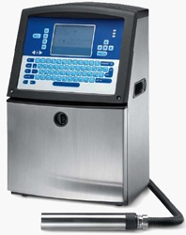 | - Stainless Steel Body  - The Machine Can Be Operational Under The Temperature Conditions Between 0 To 40c  - Print head Is Closer To The Substrate  - Inverter Mechanism Which Automatically Reciprocate The Ink Even During Non- Operational Time.  - Printing Mode-Continuous ( Change Control System)  - Character height-1 to 10 mm  - Print Speed - Max. 2666 characters/sec.  - Ink Type - Food grade ink  - Character Type - Alphabet, figures, symbols

SEMI AUTO SHRINK WRAPPING MACHINE
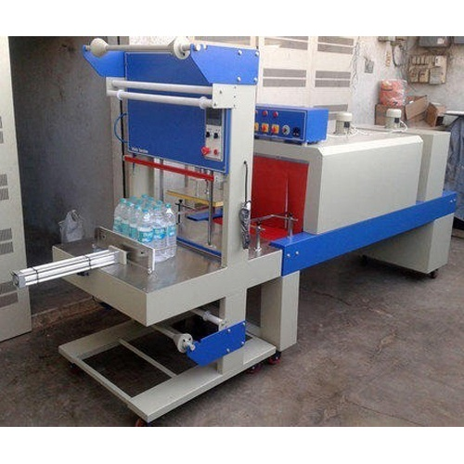
Web Sealer Specification
Sealing Dimension | 24" Sealing Arm For Sealers
Power Consumption | 18 KW
Machine Output | 5 Pack/Minute - Matrix size 4 X 3
Infeed Conveyor | SS 304 Plated Sheet
Sealing Knife | Continuously heating Teflon Coated sealing Knife 24" film guard  (thermostatically control)
Type Of Sealing | Web Sealing 2 Rolls with The Side Open.
Pneumatic | Janatics/Pneumax
Machine Construction | 16 Gauge M.S. Body Fabrication with Powder Coated Color. All Contact Parts are SS304
Film Carriage Roller | Fully Stainless Steel Material with Buffing
Air Consumption | Constant Air Pressure 100 PSI, 15CFM @7-8KG / Air req.
Tunnel Conveyor | SS Mesh Chain Conveyor
Motor & Gear Box | 1 HP Ac motor with gear box
Tunnel Opening In Mm | 1550 L X 600 W X 400 H
Heating Chamber | C-Chamber Heating Zone - 1550mm Length Insulation of Glass Wool  thickness Of 65 mm, Heat not generate of outer Body for continuous running of Machine.
Tunnel Conveyor Speed | variable speed
Heater Specification | 700mm Long, 1.5 KW SS Tube Fined Heater (12 nos. Heater)
Total Dimension In Mm | 4250 L X 1250 W X 1750 H ( Web Sealer shrink tunnel)
AC Motor | 1 HP 2800 RPM motor with 7" Impeller
Blower Fan | 0.25 HP AC motor 2800 RPM 2 no. with Aluminum Blower Fan for long performance
Cooling Zone | In exit for Tunnel provide Cooling Fan for finishing the final product.
Idler Conveyor | For Idling the product. (Drop down). Roller Conveyor 1000mm L

Price Breakup
S.N. | PARTICULERS | CAPACITY | QTY | AMOUNT
1 | Fully Automatic Bottle Rinsing, Filling, Capping Machine + Inspection Screen | 30 BPM | 1 | 8,50,000/-
2 | Automatic Flat bottle Sticker Labeling Machine | 100 bpm | 1 | 2,80,000/-
3 | Bach Coding Machine (Ink Jet Printer Videojet make) | 1 SET | 1 | 2,25,000
4 | Shrink Wrapping Machine | 1 SET | 1 | 2,85,000
 | BANK DETAIL :  Account name :- TORQ PACKAGING SOLUTION  Account number :- 8000032128  Bank name :- KOTAK MAHINDRA BANK LTD  Branch :- KATHWADA  IFSC :- KKBK0002606  COMPANY GSTIN : 24ARDPD2565K1ZX | TOTAL |  | 16,40,000/-
 |  | GST @ 18% |  | 2,95,200/-
TOTAL AMOUNT |  |  |  | 19,35,200/-
TERMS & CONDITIONS |  | For, TORQ Packaging Solution  
- 50 % Advance on Signing up of Contract
- 50% On Completion of Machinery Manufacturing Before Dispatch / During Inspection of machinery
- Order Once Placed Cannot be Cancelled
- No Refund will be entertained

